The Scottish Society for Psychical Research
(SSPR)

SC020421

Annual Report
2022 – 2023

Trustees Report Page 2

Up-to-Date Constitution Page 4

Independent Scrutineer’s Letter Page 8

Accounts Year Ending 30th Nov 2023 Page 9

Trustees Report
Year Ending Nov 30th 2023

Overview

The Scottish Society for Psychical Research continued to present its programme of eight lectures and an Annual General Meeting for 59 Members (as of AGM 2023). Meetings took place online six times and in person, three times. Despite the on-going challenges of staffing events, our three live events were well-attended and regarded as successes. The Trustees managed to expand their membership but agreed that continued outreach and recruitment was necessary.

Business of the Society

The Society fulfilled its educational charitable remit by providing eight talks and an AGM (with Cases Review) open to Members and the public (at Theosophy House, Queens Crescent, Glasgow, or online on Zoom). Our keynote speakers for this programme, were Author, Psychical Researcher and Past President of the SSPR, Tricia Robertson in conversation with Author and internationally renowned Spiritualist Medium, Gordon Smith. The event took place at the Glasgow Association of Spiritualists and was very well attended, both in person and online. Both speakers very kindly waived any expenses and therefore the evening generated significant funds for the society. Other speakers for our programme included The Edinburgh Fortean Society’s Scott Lyall talking about Mystery Apes: A Global Look at the Unknown Primate Phenomenon and Tour Guide Lynne Knight talking about Bannockburn House, Scotland’s Most Haunted House. Finally, in November 2023 we had the Author, Barrister and Chairman of The Ghost Club, Alan Murdie LLB speak to the Society about The Best Evidence for Ghosts, Poltergeists and Haunting Phenomena.

Due to the evident demand for online attendance, Council agreed to invest in livestreaming technology, e.g. laptops, video cameras and microphones. New technology when livestreaming events at Theosophy House or Somerset Place, worked with varying degrees of success. Council agreed that continued improvement, both with better audio equipment and testing would be required as hybrid live and online meetings are now expected by the public and seen as standard.

Significant time and effort was spent organising and cataloguing the library within Theosophy House, by new Council Trustee John Loughlin. Council are most grateful to John for his time and trouble. We also are grateful to the trustees of the Theosophical Society, who had to move our books to a different room, due to a paying tenant’s requirements for space. We hope to have the SSPR Library fully catalogued soon.

Cases coming into the Society during 2022 – 2023 numbered 7. There were more contacts about investigation from journalists or researchers requesting to examine our archives. Of the 7 contacts, all were handled via email correspondence or Zoom video interview. Some clients sought feedback on video footage which was provided. Some clients did not respond to further requests for information.

Governance of the Society

The Trustees, referred to in the SSPR as 'The Council', met online 6 times, from Jan 2023 to Nov 2023, and managed to supplement Council Meetings with telephone calls and email means.

On the 19th of January 2023, the Society held its Annual General Meeting. It was attended by 27 members. There were no new proposals requiring a vote.

During this year Mr John Loughlin joined Council at the January AGM but resigned in November 2023.
As of 30th of November 2023 our Trustees are:

TRUSTEES

Innes Smith Chair/President
Marysia Lessnau Vice-President/Secretary
Penny Sharp Treasurer
Jean McDougall
Derek Doran
Irene Loudon
Michael McCann
Chirsty Hamilton

On behalf of the Trustees,

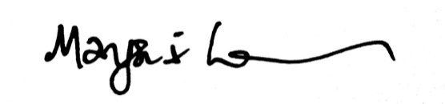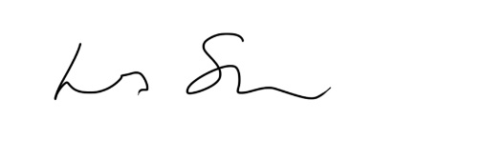

Marysia Lessnau Innes Smith
Secretary President
Vice President

CONSTITUTION OF
THE SCOTTISH SOCIETY FOR PSYCHICAL RESEARCH
Investigating The Paranormal in Scotland
SCOTTISH CHARITY Index No. SC020421 (Previous Reg. No.16608)
1. The name of the organisation shall be:-
‘The Scottish Society for Psychical Research’, hereinafter called the ‘Society’.
2. The headquarters of the Society shall be situated in Scotland.
3. The aims of the Society shall be:
(a) The investigation, in a scientific manner, of ostensible telepathy, clairvoyance, precognition, hallucinations, dreams, psychometry, and other forms of paranormal cognition; of phenomena bearing upon the hypothesis of survival of bodily death; claims of paranormal physical phenomena such as psychokinesis and poltergeists; the study of automatic writing, trance speech, alteration of personality, and other subconscious processes in so far as they may be related to paranormal processes; in short, all types of phenomena called parapsychological or paranormal.
(b) The collection, classification and study of reports dealing with the above phenomena. Names and places will be treated as confidential unless permission is given by the experiencers.
(c) The maintenance of a library on psychical research and related subjects, Contributions of books and periodical files will be welcomed.
Note: The Society holds no corporate views on any particular phenomenon.
4. The affairs of the Society shall be managed by a Council which shall consist of not fewer than five and not more than ten members elected at an Annual General Meeting (AGM). Any four members, including the President or representative and three elected members, present at a properly summoned meeting as defined under paragraph 12 hereof, shall constitute a quorum. The co-opted members shall cease to hold office immediately after the AGM. New members of the Council shall take office at the first Council Meeting after the AGM.
5. At the first Council Meeting after the AGM of the Society, the Council shall elect one of their members to be President. A neutral chairperson will preside for the election process. The new President shall then take over the chair and will be President for the period until the first council meeting after the next AGM. The retiring President shall be eligible for re-election. In the case of equality of votes when six or more councillors are present, the chairperson of the meeting shall have a casting vote.
6. One third of the members of the Council must retire annually by rotation, but are individually eligible for re-election to the Council.
7. The proceedings of the Council shall be recorded in a bound Book of Minutes and signature by the President shall indicate that the minutes are approved.

8. The Society shall hold an Annual General Meeting once every calendar year, to be notified to members of the Society at least three weeks in advance. Any 12 members, including the President or representative, shall constitute a quorum. Ten members of the Society shall be allowed to call an Extraordinary General Meeting through the Council.
9. The following shall be entitled to attend a General Meeting of the Society and vote at such meetings:
(a) Every paid-up member of the Society.
(b) The Trustees and honorary members of the Society.
10. The qualifying amount of annual subscription under sub - paragraph 9(a) above may be varied by Resolution of the Council and must subsequently be approved by an AGM.
11. The annual subscription is due for payment during the third week of October each year.
12. The Council will manage the Society and its property and exercise control over its activities.
13. It shall be the duty of the President to convene meetings of the Council either at the request of any two members of the Council, or if in his/her own judgement it is desirable that a Meeting be held, then with the consent of any two members, provided that two weeks’ notice is given. The Council shall meet at least twice a year.
14. NOMINATION OF COUNCILLORS
Each nomination shall be proposed and seconded by two members. The nominee, proposer and seconder shall be full members. The nomination may be sent to the secretary prior to the AGM or provided orally at the AGM. The nominee must indicate that he or she is willing to serve.
15. CO-OPTION OF COUNCILLORS
Co-option of additional Councillors, within the limit set out in paragraph 4, shall be subject to not less than three Councillors signing a Notice of Intention naming the additional Councillor or Councillors it proposes to co-opt; such notice is to be given such publicity among members as is reasonably available in the month prior to the next Council Meeting (without going to the cost of mailing the membership, except that all Councillors must be informed by the Secretary timeously), and shall be subject to approval by not less than a two-thirds majority of the members of Council attending the said Council Meeting.
16. COUNCIL OFFICIALS
The Council shall appoint a Secretary, a Treasurer and a Vice-President from among their own number. One person may hold any two or more of the foregoing offices.
17. The Treasurer shall present an account of expenditure since the last Council meeting at each meeting. Cheques on behalf of the Society must be countersigned by two Trustees, out of three nominated, of whom one is the President.
18. No alterations shall be made to this constitution except by a vote in favour by at least two-thirds of those present and voting at a General Meeting of the Society.
19. MEMBERSHIP
All persons 16 years of age and over who are interested in promoting the aims of the Society shall be eligible for membership. The Council shall be at liberty to refuse membership to any person.
20. MEMBERS IN ARREARS
If any member shall fail to pay the annual subscription within three months of the due date, that membership shall be deemed to have lapsed without further notice.
21. EXPULSION OF MEMBERS
The Council may by a two-thirds majority, expel any member of the Society who in its opinion does not conduct himself or herself in a fit and becoming manner. A written notice to that effect shall be sent by Recorded Delivery to the member at his/her last known address and Council shall not be bound to assign any further explanation for such expulsion but shall refund any unexpired portion of such member’s subscription calculated to the nearest month.
22. CLASSES OF MEMBERSHIP
Honorary Membership
The Council may invite and elect any person who is distinguished for knowledge and experience in the subjects of the Society’s investigations, or has rendered valuable service to the Society, to become an Honorary Member, but the Council may rescind such an election whenever they deem it desirable to do so.
Life Membership
This may be purchased on receipt of a single payment of ten times the current annual subscription.
23. Permission for any third party to reproduce or translate material from any SSPR publication must be obtained from the author and the respective editor of that publication.
24. Lectures may not be recorded without prior permission.
25. TRUSTEE ATTENDANCE
Trustees must attend council meetings regularly in person, or in the event of being unable to physically attend, by making use of modern communications technology to join in the meeting by telephone, Skype or such like. In the event of a trustee not attending council meetings, in person or via any of the widely accepted technology platforms, on three consecutive occasions the President can speak with that trustee to discuss their availability and commitment. Then, if the majority of the remaining members of council conclude that person is not able to fulfil their role in the best interests of the SSPR, they can be invited to resign from council.
26. CODE OF CONDUCT
All Members and Trustees of the SSPR must treat each other with respect and conduct themselves in a manner that does not bring the charity into disrepute. Trustees must not profit financially from their governance or association with the charity. Any reimbursement shall be in line with the Charity Regulator Guidelines on Remuneration. In short: Trustees must endeavour to act in accordance with the Charity Regulator's Guidance on Best Practice and ensure the Charity acts within all relevant laws at all times.
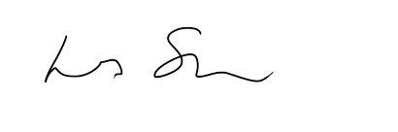
SIGNED
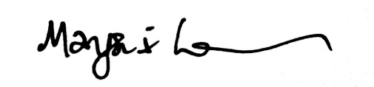
President Innes Smith
Vice President and Secretary Marysia Lessnau

Record of Amendments
AGM approved, 7th Jan. 1993, Amendment to para. 14
AGM approved, 7th Jan. 1999, Adjustment to paras. 4, 5, 11 and 16
AGM approved, 12th Jan. 2006, Adjustment to para. 11
AGM approved, 11th Jan 2007, Adjustment to para. 5 and renumbering of paragraphs 8 through 23.
AGM 10th Jan 2008: Draft version approved.
AGM approved 7th January 2010 Amendment to Clause 20
AGM approved 9th January 2013. Amendment to clause 4, Minimum number of council members to now be 10.
AGM approved 9th January 2014. Amendment to clause 4, Maximum number of council members to now be 12.
AGM approved 9th January 2014. Amendment to clause 4, number of council members to now required for quorum to be 5.
EGM approved 7th April 2016. Amendment to delete Clause 3 (c) from the Constitution
The library was never dissolved and was held in trust by a trustee; hence revisiting this issue in Sept, 2017 – and on receiving instruction from a trustee, based on advice from OSCR, the library (3c) will remain part of the constitution.
EGM approved 7th April 2016. Amendment to clause 4, to reduce council quorum to 4.
EGM approved 7th April 2016. Reduce Size of AGM Quorum from 20 to 12.
EGM approved 21st September 2017. Amendment to clause 4, number of minimum council members to be 5, maximum 10 and quorum 4.
EGM approved 21st September 2017. Amendment to clause 11, change from July 1st to Third Week in October.
AGM approved 18th Jan 2018. Amendment to clause 14.
AGM approved 18th Jan 2018. Addition of clause 25.
AGM approved 17th Jan 2019. Addition of clause 26.

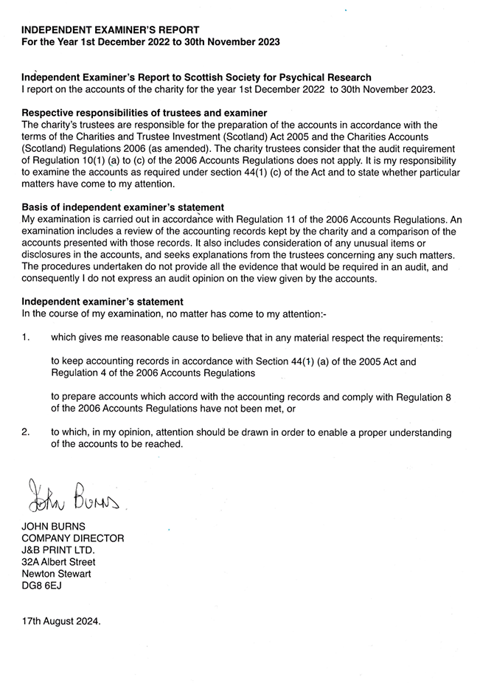
Scottish Society For Psychical Research
Scottish Charity No SC020421
Receipts & Payments Account for the year ending 30 November 2023

2023 2022
£ £
Receipts

Membership/Friends 1,210.84 1,288.33
Door/Conference 781.46 110.88
Reflection/Investigator Meetings 0.00 0.00
Donations inc. March Fundraiser 29.10 92.72
Book Sales 0.00 0.00
Miscellaneous 0.00 0.00
-------------- --------------
Total Receipts 2021.40 1,491.93
-------------- --------------

Payments

Lecture Room Hire * 80.00 270.00
Venue Hire Conference (Glasgow Uni) 0.00 0.00
Venue Hire Reflection/Investigator Meetings 0.00 00.00
Speaker Expenses 30.20 31.30
Accounts Scrutineer 101.70 101.70
Insurance 570.41 494.01
Website Expenses 0.00 0.00
Post and stationery 9.40 6.85
Email Renewal 0.00 0.00
Publicity/Advertising 143.88 0.00
Cost of Fundraising 0.00 0.00
Membership Refund 0.00 0.00
Hospitality 0.00 0.00
Sundry (inc. Library Books) 253.85 568.52
Invoices & Services (inc. Equipment) 630.41 0.00
-------------- --------------
Total Payments 1,718.15 1499.37
-------------- --------------

Profit / Deficit for year 303.25 -7.44
-------------- --------------

* Room Hire Fees for Glasgow Theosophical Society, 17 Queens Crescent G4 9BL will be invoiced & paid in next accounts

All Funds Are Unrestricted

Scottish Society For Psychical Research
Scottish Charity No SC020421
Balance Sheet as at 30 November 2023

2023 2022

Bank
Opening Balance 8721.63 8110.63
Surplus/Deficit for the Year Bank 303.25 -607.67
Surplus cash/PayPal for the year banked 0.00 1218.67

Closing Balance 9024.88 8721.63
PayPal Balance 0.00 0.00
Cash 33.22 33.22
-------------- --------------
Total Assets 9058.10 8754.85
-------------- --------------

Liabilities 0.00 0.00
-------------- --------------
Net Assets 9058.10 8754.85
-------------- --------------

Reserves
Opening Balance 8754.85 8762.29
Surplus for the Year 303.25 -7.44
-------------- --------------
Closing Balance 9058.10 8754.85
-------------- --------------

All funds are unrestricted
Approved by the Trustees and Signed on their behalf

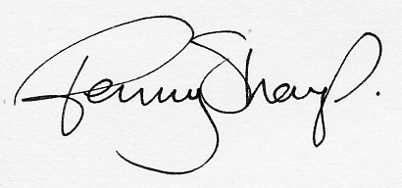
Penny Sharp
Treasurer
07/08/24

