
The Ubiquitous Chip

Thank you for sharing your experience with The Scottish Society for Psychical Research. We are a Registered Scottish Educational Charity SC020421 and your account will help us investigate the premises in a scientific manner. Any information you provide us will be held in accordance with best practice Data Protection legislation and we will not use your information for any other reason than for psychical research. If you are happy to speak to us more about your experience, then provide your contact details, otherwise we will assume you want no further contact.
If you have any questions, please contact us through our website: thesspr.com.

Please fill in all parts of this questionnaire

Name (this will be anonymized in the future report)__________________________________________

Staff or Client/ Customer or Service Provider (please clarify)_______________________________

Contact Details if you want to be contacted (Tel/Mob/Email)_______________________________

_____________________________________________________________________________

Initial Questions (Please circle a number from 0 to 5)

Before your experience, did you know anything about this building (history, etc)?

⇐ Know nothing Know something Know lots ⇒
0 | 1 | 2 | 3 | 4 | 5

Before your experience, did you know anything about this building being haunted?

⇐ Know nothing Know something Know lots of stories ⇒
0 | 1 | 2 | 3 | 4 | 5

Before your experience, how often were you in this building?

⇐ This is my first visit! A few times before Lots of times (regular!) ⇒
0 | 1 | 2 | 3 | 4 | 5

How often do you experience the paranormal (or psychic or spiritual)?

⇐ Rarely, if at all Occasionally All the time ⇒
0 | 1 | 2 | 3 | 4 | 5

About your Beliefs - Thalbourne’s Paranormal Belief Scale

This page is a questionnaire often used in parapsychology. It presents a set of statements, each expressing an attitude about some aspect of ESP. Please circle one of the options, where SA means you strongly agree, A means you agree, D that you disagree, and SD that you strongly disagree. You may find the following definitions helpful when completing this questionnaire:
ESP = psychic reception of information without the use of the senses or reasoned guesses
PK = psychic influence on physical objects by the force of mental will power alone

- I am convinced that ESP exists. SA A N D SD
- I am convinced that I have had a personal experience of ESP. SD D N A SA
- I am convinced that I am psychic. SA A N D SD
- I am convinced that it is possible to gain information about the
future before it happens in ways that do not depend on common
sense or the ‘normal senses’ (sight, hearing, etc). SD D N A SA
- I am convinced that I have had at least one hunch that turned out
to be correct and which (I believe) was not just a coincidence. SA A N D SD

- I am convinced that I have had at least one premonition about the
future that came true and which (I believe) was not just a coincidence. SD D N A SA
- I am convinced that I have had at least one dream that came true
and which (I believe) was not just a coincidence. SA A N D SD
- I am convinced that I have had at least one waking vision that was not
an hallucination and from which I received information that I could not
have otherwise gained at that time and place. SD D N A SA
- I am convinced that there is life after death. SA A N D SD
- I am convinced that it is possible to contact spirits of the dead. SD D N A SA

- I am convinced that it is possible to gain information about the thoughts,
feelings or circumstances of another person, in a way that does not
depend on common sense or the ‘normal senses’ (sight, hearing, etc). SA A N D SD
- I am convinced that it is possible to send a ‘mental message’ to
another person, or in some way influence them at a distance, by
means other than the normal channels of communication. SD D N A SA
- I am convinced that I have had at least one experience of telepathy
(where I became aware of another person’s thoughts or sensations
in a way that was not due to common sense or the ‘normal senses’
of vision, hearing, etc) between myself and another person. SA A N D SD
- I am convinced that psychokinesis (PK) exists; that is, the direct
influence of mind on a physical system, without the use of any known
physical energy (as in, for example, psychic healing, affecting the roll
of dice, bending spoons or moving objects). SD D N A SA
- I am convinced that on at least one occasion I have personally
exerted PK, where my mind apparently directly influenced the physical
world in some way, without the use of any known physical means. SA A N D SD

- I am convinced that I have strong or reliable PK ability. SD D N A SA
- I am convinced that, on at least one occasion, I have witnessed an
apparently psychokinetic effect on physical objects which I cannot
explain in terms of a normal physical effect. SA A N D SD
- I am convinced that I have witnessed – in the past or at present –
persistent physical disturbances, that seemed to be caused by PK
(as for example, a ‘poltergeist’). SD D N A SA
What you already knew about the Ubiquitous Chip before your experience
History, Gossip and any Knowledge of Paranormal Activity (and where in the building)
(Write on reverse side if necessary)

Your Experience(s) plus NUMBER SCORING explained

In as much detail as possible, describe your experience. Include where you were at the time, what you were doing, time of day, etc, etc. Please note, on the following page there is a floorplan to help you specify any exact location. If you have multiple experiences, then please ensure you describe each one and location.
We are also asking you to rate your anomalous experience on a scale from 0 to 5 (with 0 being nothing weird or unusual at all, and 5 being something unambiguously paranormal). This helps us with further investigations into the premises and provides us with a tangible data set. Please write your number score where you had the experience.

FLOORPLANS

Please use the floorplans and the alpha-numeric grid to tell us where you had your experience. If you had more than one experience, or want to point out several locations, then please do so – and specify clearly below.

Also: if you’ve not already done so, NOTE YOUR SCORE BETWEEN 0 and 5 of PARANORMALITY
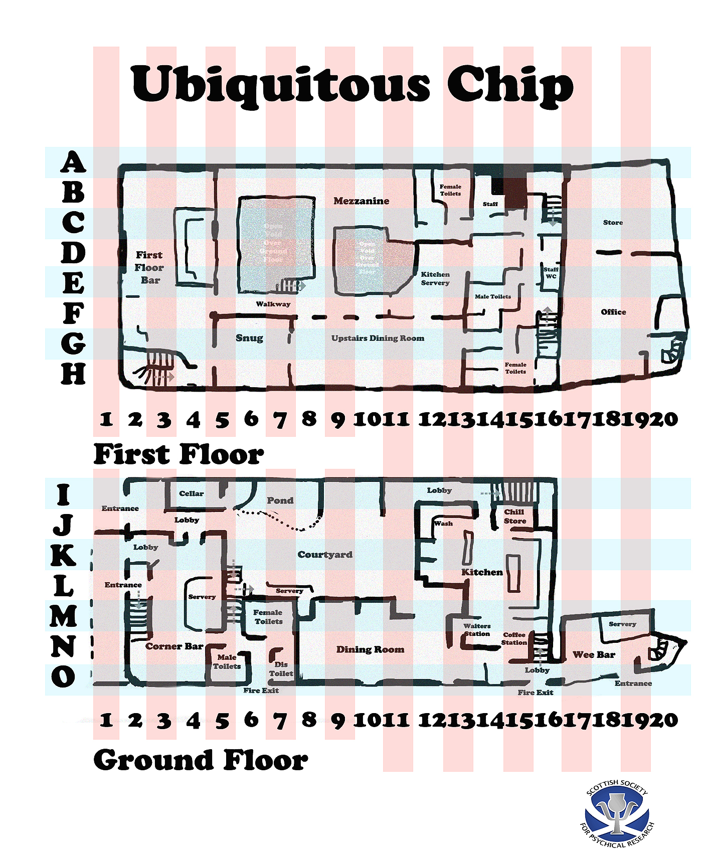

LOCATION(s): (and Score if not already given): __

